Tableau Day 3 - Exercises

Exercise 1

1. Import the ‘employee.csv’, ‘department.csv’ and ‘project.csv’ files into Tableau. An auto join will be performed for all 3 tables. If not, go back to the data source tab and change to inner join. Ensure that it is an inner join.

Answer:

1. On a new sheet, create a vertical bar chart to show average Years Of Experience for each Dept Name.

Answer:

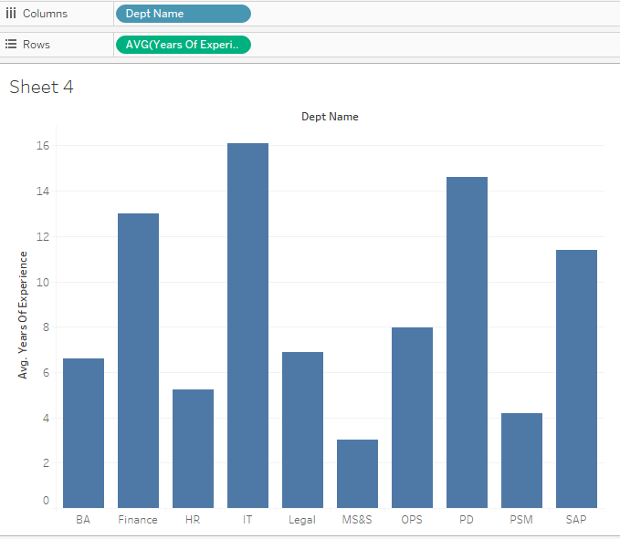

1. Add a filter to the above bar chart to only include Project Names BA101 and IT111.

Answer:

Show filter by right-clicking on Project Name in the Filter shelf and selecting Show Filter. You will notice that the Project Name filter appears on the right side of the screen.

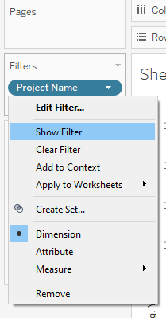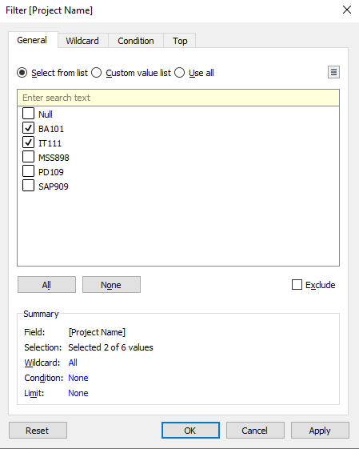

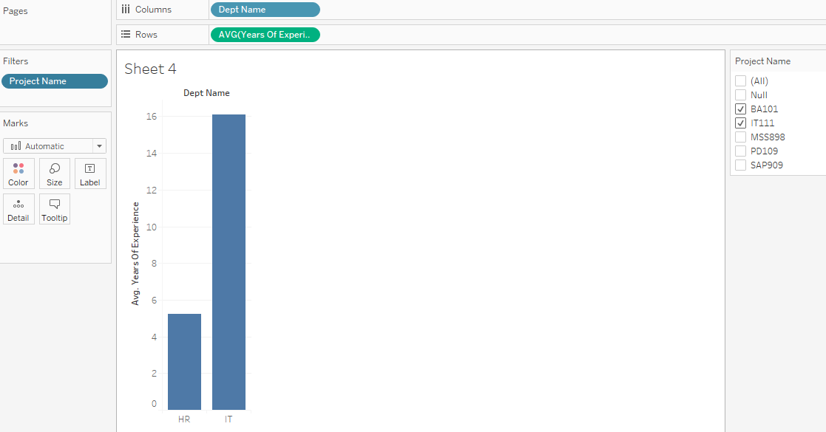

1. Answer the following questions by changing the filter options.
   1. What is the average Years Of Experience for an employee working on Project MSS898?

Answer: 3.033

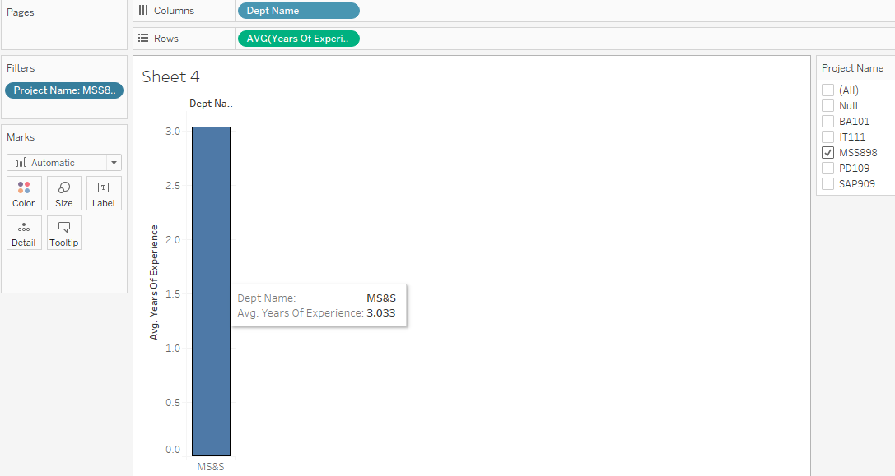

* 1. Out of Projects PD109 and SAP909, which project has employees with fewer Average Years Of Experience?

Answer: SAP909

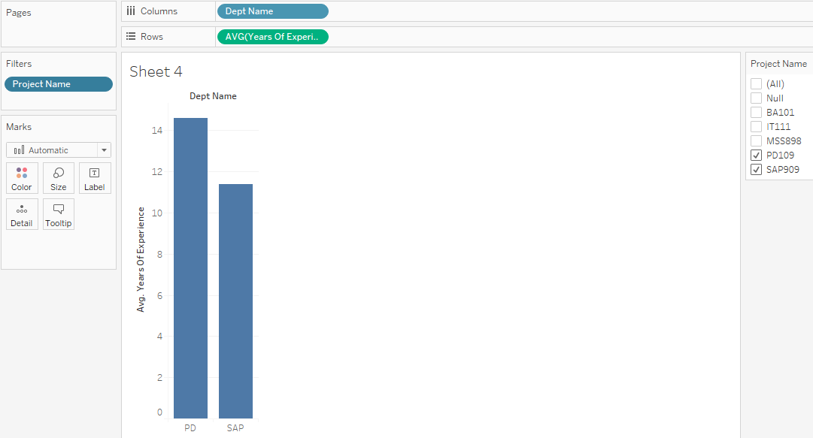

1. Now, add a filter for Average Employee Age to the chart. Which Dept Names have an average Employee Age between 30 and 40 years?

Answer:

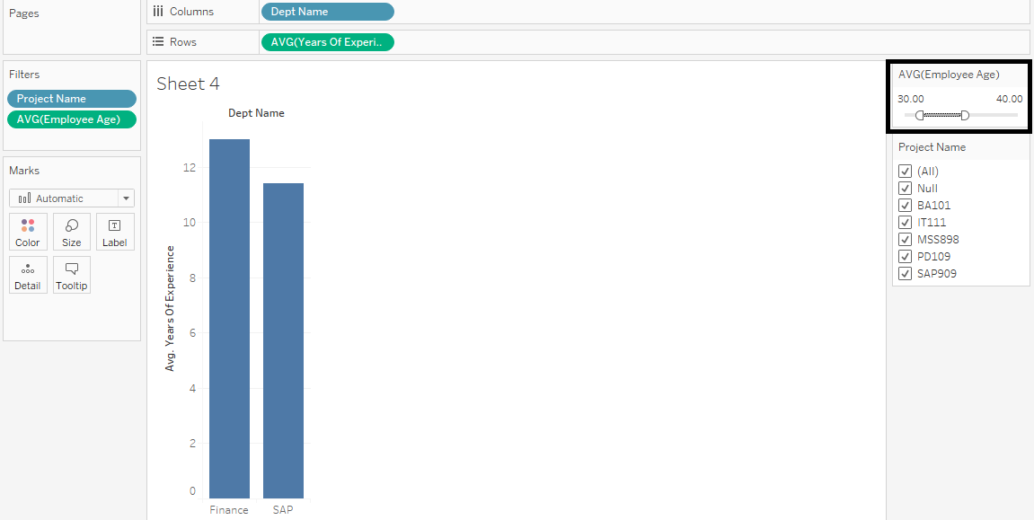

Finance and SAP departments have Average Employee Age between 30 and 40 years.

1. Draw a bar chart of total_hours_of_work on the x-axis versus both dept_id and project_id on the y-axis.

Answer:

On a new sheet, drag the total_hours_of_work to the columns. Drag the dept_id and project_id to the Rows in the worksheet.

1. Add marks to this chart in any Green shade using the ‘Label’ button in the ‘Marks’ pane.

Answer:

This can be done by clicking on the ‘Label’ button and checking the ‘Show marks labels’.

1. Annotate the department and project with the highest hours of work.

Answer:

Right click in the area where the total_hours_of_work is maximum. Then click on Annotate -> Point. By default, total_hours_of_work: <SUM(total_hours_of_work)> must be generated. Upon clicking OK, the annotated box is visible.

Exercise 2

1. Use the employee table and plot a bar chart of dept_id in Columns and AVG(years_of_experience) in the Rows. Now create a function to calculate the median of years_of_experience. Add the function to Rows.

Answer:

1. In a new sheet, calculate the average percentage of total_years_of_experience.

Answer:

3. Now split the chart by project name.

Answer:

